**JDK vs JRE vs JVM:-**

**JDK (Java Development Kit):- It is provides environment to develop and run our java applications.**

**JRE (Java Runtime Environment) :- It is provides environment to run our java applications.**

**JVM (Java Virtual Machine) :-It is an interpreter they convert our byte code into binary code (machine code) and it is responsible to run java applications line by line.**

**Note:-**

**JVM is the part of JRE whereas JRE is the part of JDK**

**JDK =JRE + Development Tools**

**JRE = JVM + Libraries**

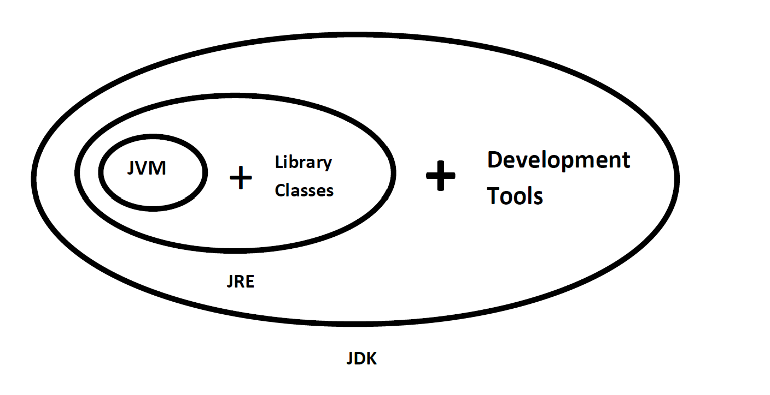

**Steps to prepare First Java Application:**

1. **Download jdk for windows operating-system.**
2. **Install Java Software(JDK)**
3. **Set path.**
4. **Select Java Editor**
5. **Write Java Program**
6. **Save Java File**
7. **Compile Java File**
8. **Execute Java Application**

**Install Java Software(JDK):-We install Java Software(JDK) like normal software, we have not required do any extra thing.**

**Set path:-After installation of JDK software, we have to required set "path", through the path we describe the location where all JDK commands are existed and that path is "C:\Java\JDK1.8.0\bin", so this location to make available all JAVA commands to Operating System.**

**There are two ways to path:-**

1. **Command Prompt level.**
2. **Environment level.**

**Command Prompt level:-Set path at Command Prompt level is temporary once we close the command prompt we lost the path.**

**We set the path at command Prompt level by using following steps:-**

**Step:-1 Open the command prompt**

**Step:-2 Type following command on command prompt.**

**set path=C:\Java\JDK1.8.0\bin;**

**Environment level:-Set path at environment level is permanent, either close the command prompt or shutdown the system we never lost path. We set the path at environment level we follow following steps.**

1. **Right Click on Computer icon.**
2. **Select "Properties".**
3. **Click on "Advanced System Settings".**
4. **Click on "Advanced" Tab[By default Selected].**
5. **Click on "Environment Variables.." button.**
6. **Go to System Variables part and click on "New" button.**
7. **Paste path location C:\Java\jdk1.8.0\bin";**
8. **Click on "Ok" button.**
9. **Click on "OK" button.**
10. **Click on "OK" button.**

**Select Java Editor:-**

**Editor is a software, which will provide very good environment to write and save our java programs.**

**EX: Notepad, Notepadplus, Editplus,....etc**

**Write Java Program:-**

**class Test**

**{**

**public static void main(String[] args)**

**{**

**System.out.println("First Java Application");**

**}**

**}**

**Save Java File:- We save java program in our system by using following protocol.**

**class name with .java extension.**

**Example:-Test.java**

**Where Test is class name.**

**Compile Java File:-Compile java file by using following command.**

**Go to directly where java source is available.**

**javac source_code_name.java**

**javac Test.java**

**After compilation we get .class file which contains byte code.**

**Execute Java Application:-Execute java application(.class file) by using following command.**

**java .class_file_name**

**java Test**

**Output:- First Java Application**